|  |  |  |
| --- | --- | --- |
|  | **St Thomas More Catholic Primary,**  **A Voluntary Academy**  **2023/24 Newsletter – Issue 26**  **Week Commencing – 25 March 2024**  **Creswick Lane, Grenoside, Sheffield, S35 8NN T: 0114 2468020**  **e-mail:**[**enquiries@st-thomasmore.sheffield.sch.uk**](mailto:enquiries@st-thomasmore.sheffield.sch.uk) **Visit our website:** [**www.st-thomasmoresheffield.co.uk**](http://www.st-thomasmoresheffield.co.uk/) |  |

**Happy Easter**

We would like to wish all our families a Happy and Holy Easter. We hope that you enjoy the holidays and we will be returning to school on **Monday 1st April**

**Important Dates:**

**Thursday 28 March 2024**

Online/remote learning

**Friday 29 March & Monday 1 April 2024**

Bank Holidays – School Closed

**Tuesday 2– Friday 12April 2024**

Easter Holidays

**Tuesday 16 April 2024**SEND Parents’ Session 3:30pm – 5pm

**Thursday 18 April 2024**

Y5 Sports Summit @ EIS Sheffield  
*Please arrive at school by* ***8:30am***  
**Friday 19 April 2024**F2 Trip to Magna

**Tuesday 23 April 2024**  
M&M Theatrical production of Jungle Book £6)

**Wednesday 24 April 2024**

Y3 Tag Rugby @ Chesterfield Panthers   
*Please arrive at school by* ***8:20am*  
Monday 29 April – Friday 3 May**Y5 Bikeability (in school)

**Tuesday 30 April 2024**

Y4 Mini Tennis @ Graves Places for People

**Monday 6 May 2024**

Bank Holiday – School Closed

**Monday 20 May – Wednesday 22 May 2024**

Y4 Residential to Kingswood (Peak Venture)  
**Friday 24 May 2024**  
Inset Day – School Closed  
**Monday 27 May – Friday 31 May 2024**  
Half Term – School Closed

**Thursday 6 June 2024**

Y6 Mini Tennis @ Graves Leisure Centre

**Tuesday 11 June 2024**

Y3 Derby County Football @ Derby County Training  
**Thursday 27 June 2024**  
Y2 Trip to William’s Den  
**Tuesday 9July 2024**  
Y2 Walk to Library @ Parson Cross

**Wednesday 10July**

Y1 Trip to Yorkshire Wildlife Park



**5 Fun Facts about Easter!**

1. Painting eggs comes from Ukraine!
2. Pretzels are associated with Easter, as the twists resemble arms crossing in prayer.
3. Easter is always celebrated on the Sunday after the first full moon, which is on or after March 21st. This is why the date changes each year.
4. The world’s biggest Easter egg was more

than 34 feet tall.

1. The most expensive chocolate egg sold

for £7,000!

6.

7.

8.

9.

10.

Jesus said: “Love one another as I have loved you.”

**At St Thomas More our Mission is to love and to become the wonderful person God created us to be**

|  |  |  |
| --- | --- | --- |
|  | **Whole School Information** |  |



**After School Club Information**

The club has the children participating in different and fun activities each day. The club is split into three different sessions which are listed below:   
Bookings can be made via [Parent Mail](https://pmx.parentmail.co.uk/) up until **3pm the previous day**. After this time bookings can be made by contacting the school office. For the parents whose children attend after school club, please don’t hesitate to get in touch and leave any feedback!

|  |  |
| --- | --- |
| 15:20 - 16:15 | The children will take part in a different activity until it is time to be collected (£3) |
| 15:20—17:00 | The children will take part in a different activity and will be given a choice of either a hot or cold food followed by a snack such as fruit or a sweet treat. (£6) |
| 15:20—18:00 | The children will take part in a different activity and will be given a choice of either a hot or cold food followed by a snack such as fruit or a sweet treat before either starting a new activity or carrying on with the previous one. (£8) |

**Please note: *NO After School Club on Thursday 9 May 24 and Wednesday 5June 24***

|  |  |  |
| --- | --- | --- |
|  | **Whole School Information** |  |

**Sheffield Star Newspaper Report 25/05/2024**





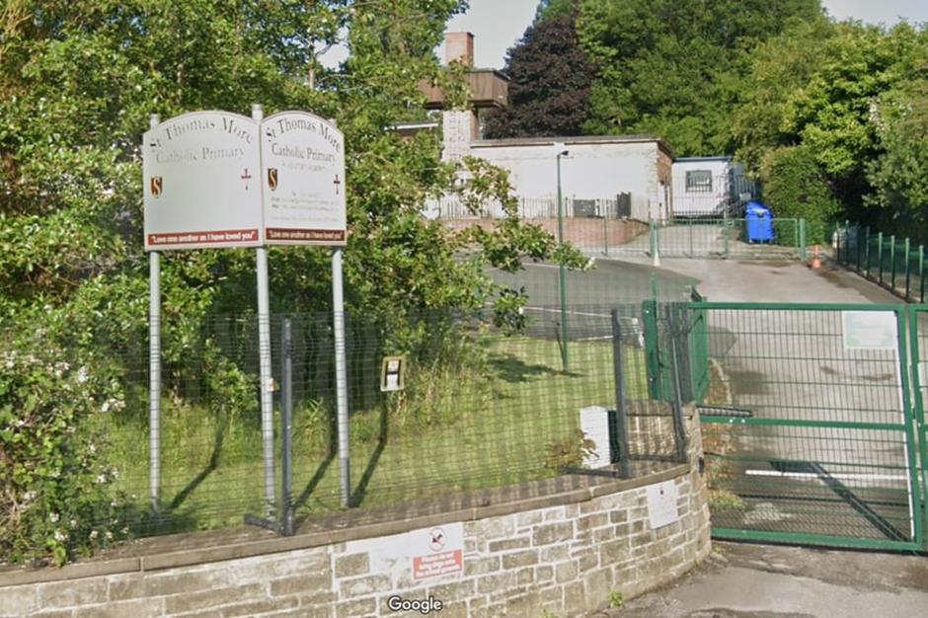

|  |  |  |
| --- | --- | --- |
|  | **Whole School Information** |  |

**TimesTables RockStars**

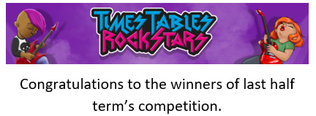

**We are running three Times Tables Rockstars competitions this half term. Each week we will be updating you on the scores via Dojo.**

**Y2 Group 1 v Y2 Group 2  
Y3 v Y4  
Y5 v Y6**

Please encourage your children to take part in this at home, as the winning classes/groups will be given a special certificate for their efforts.



|  |  |  |
| --- | --- | --- |
|  | **Whole School Information** |  |



**A Culture of Safeguarding at St Thomas More**

](https://nationalcollege.com/guides/10-top-tips-for-parents-and-educators-encouraging-open-conversations-at-home)

|  |  |  |
| --- | --- | --- |
|  | **Whole School Information** |  |



**SEND and Inclusion News**





From recent feedback from parents, we have decided to have our next SEND parents meet-up during an afternoon session rather than morning so that more parents can attend. The session will be on:

**Tuesday 16 April 2024 - 3:30pm-5pm.**

The sessions are specifically aimed at those parents who have a child in school with a special educational need and/or disability. However, the sessions are inclusive so therefore all parents/carers of children attending our school are welcome.

These sessions are designed to share information about provision in school; share links with key agencies; share opportunities for our children with SEND within the community as well as the opportunity for parents/carers to informally meet one another, share experiences and ask questions. It is always great to realise that you are not alone on this journey; there are many parents treading a similar path!

For this session, we are very lucky to have an Educational Psychologist attending: Dr Josie Faure Walker. She will be delivering a short workshop to support parents with dealing with emotional and mental health. She will give some key information about emotional dysregulation, sensory needs and strategies to support children.

These sessions will take place every half term and I hope in the future to invite other key professionals to join each as guest speakers to allow you find out more about their service, ask questions and collect some hints and tips.

If you would like to join us on Tuesday 16 April 2024 - 3:30pm-5pm, please complete the link below:

<https://forms.office.com/e/wm9Wp1CFrv>

Thank you,

**Mrs Round**

**SEND Parents’ Session**

|  |  |  |
| --- | --- | --- |
|  | **Whole School Information** |  |





|  |  |  |
| --- | --- | --- |
|  | **Whole School Information** |  |

](https://ecclesfield-pc.gov.uk/bee-squared-2024-lets-get-planting/)



|  |  |  |
| --- | --- | --- |
|  | **Trips and Events** |  |



**STM Sporting Events and Competitions 2024**

|  |  |  |  |
| --- | --- | --- | --- |
| **Event** | **Year** | **Venue** | **Date/Time** |
| Bikeability | Y5 | In School | 29/04/24 - 03/05/24 |
| Mini Tennis | Y4 | Graves Places for People | 30/04/24 9:30am – 12pm |
| Mini Tennis | Y6 | Graves Leisure Centre | 06/06/24 9:30am – 12pm |
| Derby County Football | Y3 | Derby County Training Ground | 11/06/24 9:30am – 12pm *(please arrive at school by 8am promptly for the coach)* |
| Football District | Y6 | Derby Country Training Ground | 14/06/24 9:30am – 12pm *(please arrive at school by 8am promptly for the coach)* |
| Water Polo | Y5 | Graves Places for People | 18/06/24 9am – 11:30pm |
| Netball District | Y5 | EIS Sheffield | 28/06/24 9:30am – 12:30pm |
| EIS Sports Day | Y2/Y6 | EIS Sheffield | 11/07/24 9:00am – 3pm *(please arrive at school by 8:20am for the coach)* |
| Tag Rugby | Y5 | Mount St Mary’s | 16/07/2024 – 9:30am – 1pm |
| Kwik Cricket | Y4 | Mount St Mary’s | 17/07/2024 9:30am – 1pm |

**MORE SPORTS EVENTS TO FOLLOW**

There will be no cost to parents/carers for any of the above events.

These events, including transport will be fully funded from the school’s premium grant.

|  |  |  |
| --- | --- | --- |
|  | **Trips and Events** |  |

|  |  |
| --- | --- |
|  | F2 Magna trip |
| Time Clock Clip Art - Cliparts.co | Friday 19 April 2024 |
| drop off clipart 20 free Cliparts | Download images on Clipground 2023 | Normal time |
| Geo Location Pin vector icon 552361 Vector Art at Vecteezy | [Magna](https://www.visitmagna.co.uk/) |
| Free Travel Black And White Clip Art with No Background - ClipartKey | Coach |
| British pound clipart - Clipground | The cost of the trip is £19.00 per child. If we do not receive enough contributions, the trip may have to be cancelled |
|  | F2 will be going to Magna Museum for a fun filled adventure day out on Friday the 19April 2024.They will be taking part in a dinosaur detective workshop where they’ll be digging for fossils and following footprints to discover which dinosaur was the culprit. They will also explore the pavilions and play on the adventure playground, weather permitting. Children will need a water bottle and pack lunch (which can be ordered through school if you wish) |



|  |  |  |
| --- | --- | --- |
|  | **Trips and Events** |  |

|  |  |
| --- | --- |
|  | Y1 Trip to Yorkshire Wildlife Park |
| Time Clock Clip Art - Cliparts.co | Wednesday 10h July 2024 |
| drop off clipart 20 free Cliparts | Download images on Clipground 2023 | 8:40am |
| Geo Location Pin vector icon 552361 Vector Art at Vecteezy | [Yorkshire Wildlife Park](https://www.yorkshirewildlifepark.com/) |
| Free Travel Black And White Clip Art with No Background - ClipartKey | Coach |
| British pound clipart - Clipground | The cost of the trip is £21.50 per child. If we do not receive enough contributions, the trip may have to be cancelled |
|  | Y1 will be going on a trip to Yorkshire Wildlife Park on Wednesday 10 July 2024. The cost of the trip per child is £21.50.Students will need to arrive in school at the earlier time of 8.40am for the coach to leave at 9am and then will need to be picked back up at 2.00pm to arrive back to school for around 3pm.Children will need a water bottle and pack lunch, or will need to order a school packed lunch. |



|  |  |  |
| --- | --- | --- |
|  | **Trips and Events** |  |



|  |  |
| --- | --- |
|  | **Y2 Trip to William’s Den** |
| **Time Clock Clip Art - Cliparts.co** | **Thursday 27 June 2024** |
| **drop off clipart 20 free Cliparts | Download images on Clipground 2023** | Normal time |
| **Geo Location Pin vector icon 552361 Vector Art at Vecteezy** | [**William’s Den**](https://www.williamsden.co.uk/) |
| **Free Travel Black And White Clip Art with No Background - ClipartKey** | Coach |
| **British pound clipart - Clipground** | The cost of the trip is **£23.00** per child. If we do not receive enough contributions, the trip may have to be cancelled |
|  | Y2 will be going on a trip to Williams Den on **Thursday 27 June 2024**.  They will be going on a nature walk to support their learning in science and they will also be making use of the amazing playgrounds as a reward for all their hard work this year!  The cost for this trip will be **£23.00** – which includes the full day at Williams Den and return coach.  We will be leaving at **8:45am** so we are asking that children are dropped off at school by **8:20am** on this day please.  Hopefully the weather will be great so please ensure your children are given sunscreen to apply themselves.  **Please indicate if you would like your child to have packed lunch provided through school or if they will be bringing one from home.** |



|  |  |
| --- | --- |
|  | **Y2 Walk to Local Library at Parsons Cross** |
| **Time Clock Clip Art - Cliparts.co** | **Tuesday 9 July 2024** |
| **drop off clipart 20 free Cliparts | Download images on Clipground 2023** | Normal time |
| **Geo Location Pin vector icon 552361 Vector Art at Vecteezy** | **Parson Cross Library** |
| **Free Travel Black And White Clip Art with No Background - ClipartKey** | Walking |
| **British pound clipart - Clipground** | No payment required |
|  | On **Tuesday 9 July 2024**, Y2 will be walking to the Local Library at Parson Cross.  Students will be leaving school at **9:45am** to arrive at the Library for **10am.** The children will be able to explore the library and read books, supported by school staff, volunteers and the Librarians. Students will be back in time for their school lunch.  **Please let the school office know if you do not want your child to attend.** |

|  |  |  |
| --- | --- | --- |
|  | **Trips and Events** |  |



|  |  |  |
| --- | --- | --- |
|  | **Trips and Events** |  |

|  |  |
| --- | --- |
|  | Y4 Residential to Kingswood (Peak Venture) |
| Time Clock Clip Art - Cliparts.co | Monday 20 May 2024 - Wednesday 22 May 2024 |
| drop off clipart 20 free Cliparts | Download images on Clipground 2023 | Normal school time, the children leave around lunchtime on Monday. |
| Geo Location Pin vector icon 552361 Vector Art at Vecteezy | [Peak Venture Yorkshire | Outdoor Education | Kingswood](https://www.kingswood.co.uk/locations/peak-venture) |
| Free Travel Black And White Clip Art with No Background - ClipartKey | Coach |
| British pound clipart - Clipground | The cost of the trip is £235.00 per child |
|  | Exhilarating Adventure Park with apparatus including a zip wire, 3G swing and leap of faith, plus specially designed bush craft sessions and nature walks.Flexible indoor space for all weather activities including fencing and indoor initiatives. Located adjacent to our water sports area, situated on the Scout Dike Reservoir, offering exciting activities including canoeing and raft building.Other facilities: Diner, shop, social hubs, party leader lounges, indoor classroom spaces. Offering each child an opportunity to increase their resilience, grow their confidence and develop their character.The cost of the trip is £235 per child. This includes: --Travel-Accommodation for 2 nights-Activities over the 3 days-Meals over the 3 days The full balance for the trip needs to have been paid by **28 March 2024.** If you wish to discuss anything about costs, please do not hesitate to contact the school office. Here is a link to the Peak Venture website: [Peak Venture Yorkshire | Outdoor Education | Kingswood](https://www.kingswood.co.uk/locations/peak-venture) |

|  |  |  |
| --- | --- | --- |
|  | **Trips and Events** |  |



|  |  |  |
| --- | --- | --- |
|  | **Trips and Events** |  |

|  |  |
| --- | --- |
|  | Year 6 Trip to Whitby |
| Time Clock Clip Art - Cliparts.co | Monday 24 June until Wednesday 26 June 2024 |
| drop off clipart 20 free Cliparts | Download images on Clipground 2023 | TBC |
| Geo Location Pin vector icon 552361 Vector Art at Vecteezy | [YHA Whitby Abbey Hostel | Accommodation Whitby](https://www.yha.org.uk/hostel/yha-whitby) |
| Free Travel Black And White Clip Art with No Background - ClipartKey | Coach |
| British pound clipart - Clipground | The total cost of the trip is £180.Once confirmed, please make the deposit of £20 and provide consent on [ParentMail.](https://pmx.parentmail.co.uk/) |
|  | We are pleased to announce that we are offering a **2-night residential** to this year’s class six pupils on **Monday 24 June 2024 until Wednesday 26 June 2024**. The children will be staying at the Youth Hostel in Whitby next to the Abbey.  The stay will include all accommodation, including 3 meals - breakfast, lunch and dinner, and refreshments during the stay. The cost to parents will also include the coach to and from Whitby. The cost for the transport and accommodation including all meals and supervised activities per child is **£180**.  We will be offering an information session for parents to attend in the near future to find out more about the activities the children will be participating in and further information on the YHA Whitby Centre. We will also be giving you information on clothing and footwear the children will need for the trip. For now,  We would like you to confirm if you would like your child to take part in the Y6 Residential trip and include a **£20 deposit**, payment is available on [ParentMail](https://pmx.parentmail.co.uk/) , this is needed to secure the booking with the YHA in Whitby.  Payments can be made in instalments, with the full balance needing to be paid by **22 April 2024**. |

